Mapping the world
St Paul’s Catholic School Geometry Workshop III
Welcome to the third geometry workshop at St Paul’s. Today we’ll be looking at the maths of projections and the creation of maps. Flat maps are more useful than globes, but can we actually make maps that represent the Earth in an accurate way? Are some projections better than others?

Mercator projection

The Mercator projection is a cylindrical map projection created by Gerardus Mercator in 1569. It became the standard map projection for nautical purposes because of its ability to represent lines of constant course, known as rhumb lines or loxodromes, as straight segments which conserve the angles with the meridians.
How does it work?
You can think of it as wrapping a cylinder around the globe and then moving the points from the globe to the cylinder as if there was a light in the centre of the sphere. Finally, the cylinder is squeezed vertically so that the parallels are not so spaced away.
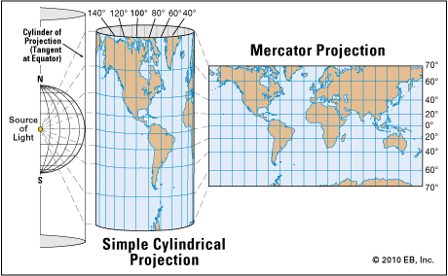
Activity 1: Order, from largest to smallest, the following countries: Argentina, Australia, Brazil, China, Greenland and India.

1 |  |  | 4
2 |  |  | 5
3 |  |  | 6
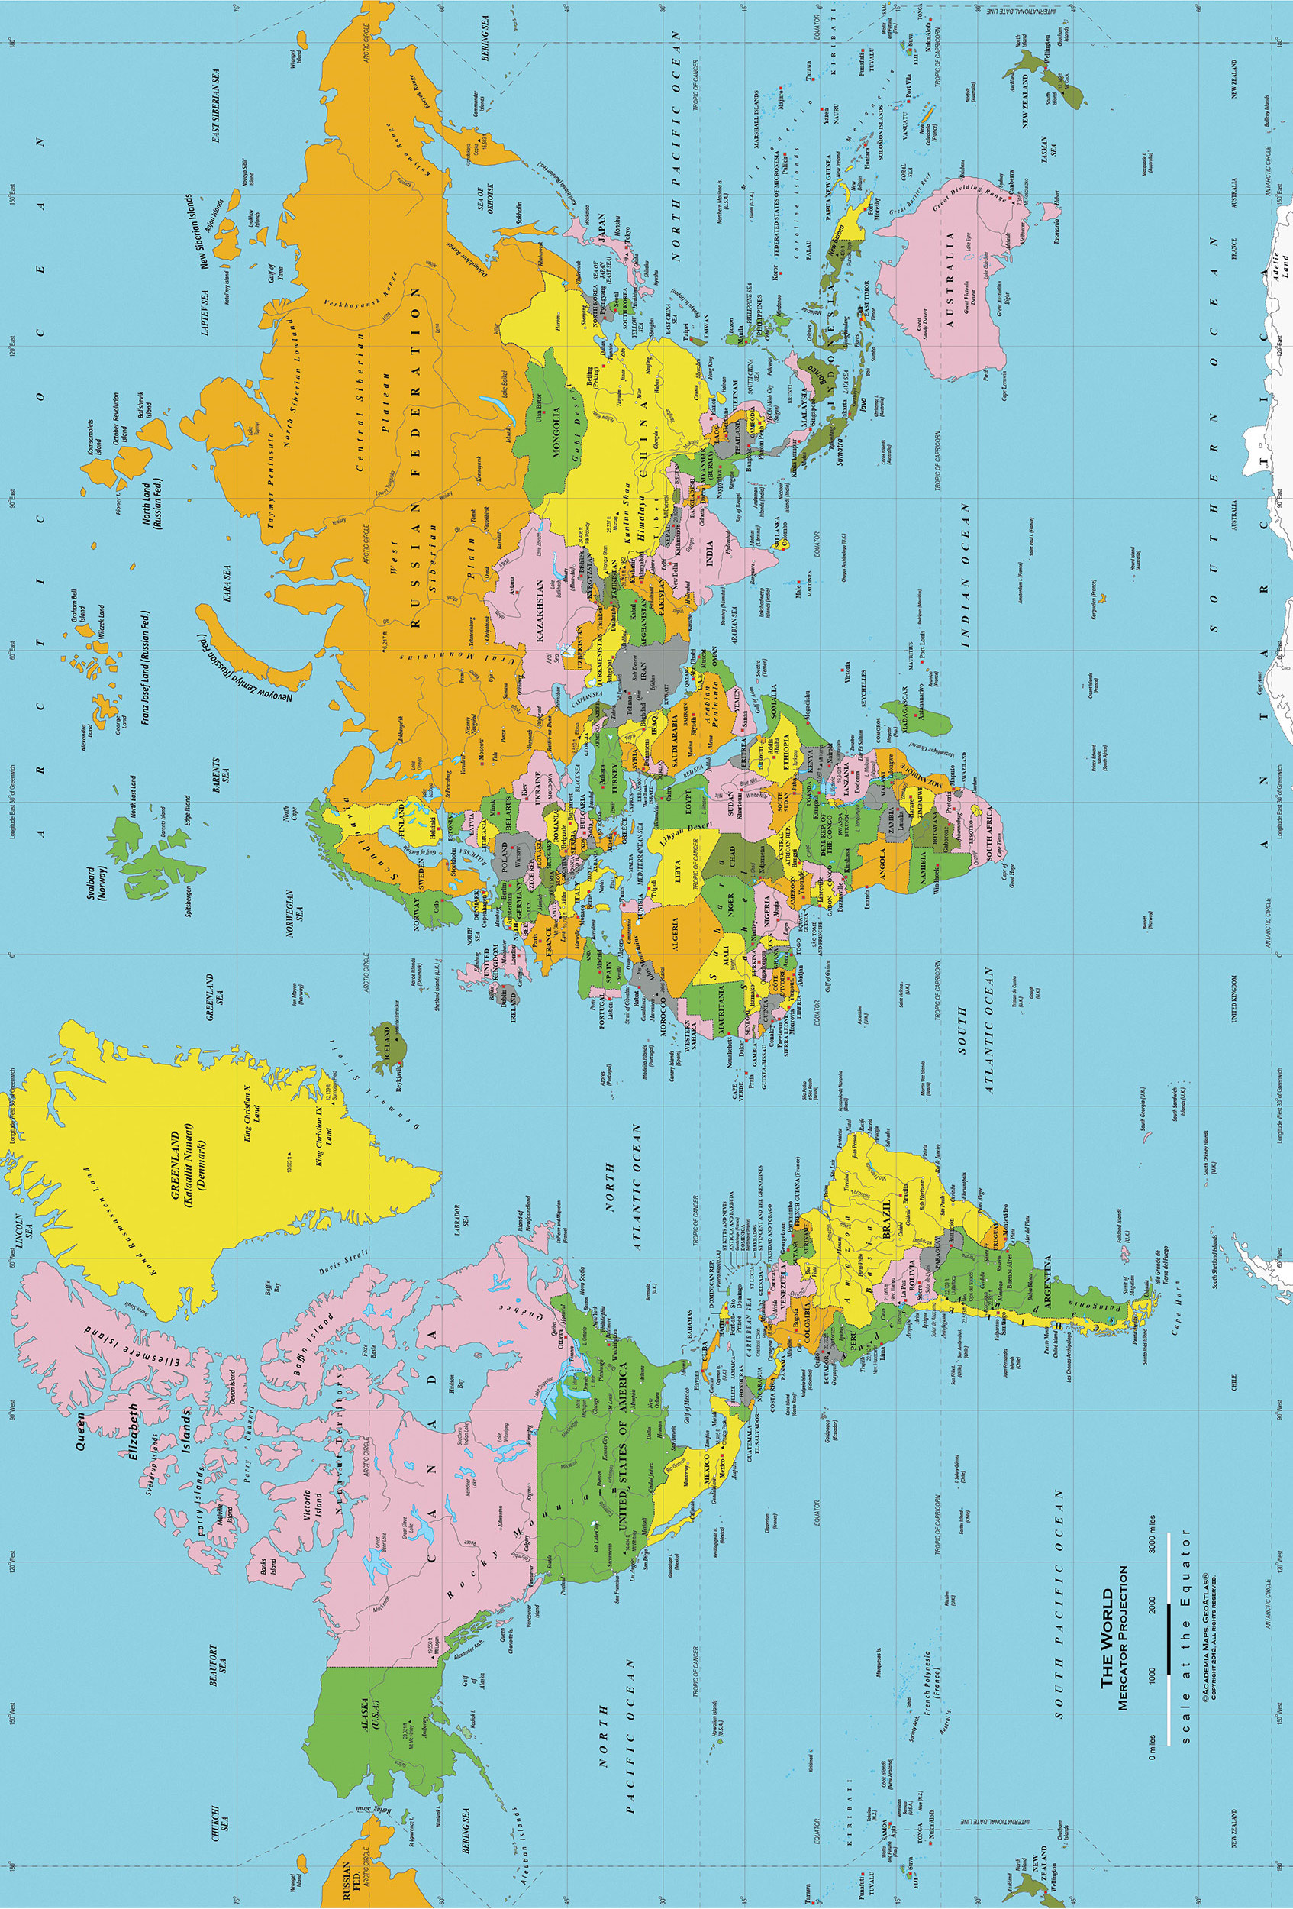
Mercator’s projection preserves angles but distorts areas. In fact, Australia is more than three times bigger than Greenland! Tissot’s indicatrix is a mathematical tool that gives you information about the distortion of the map (the bigger the red circle the more distorted).
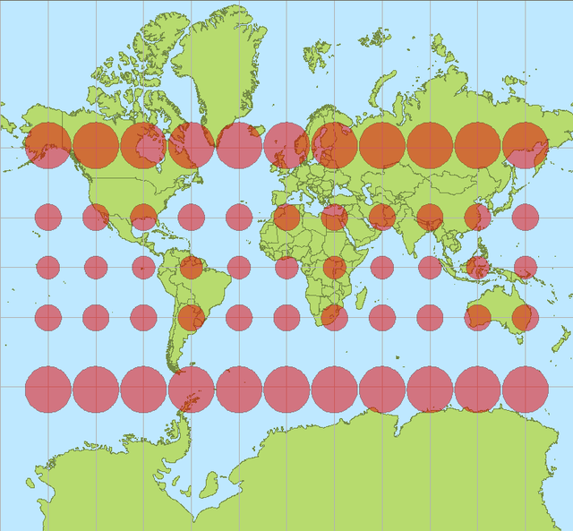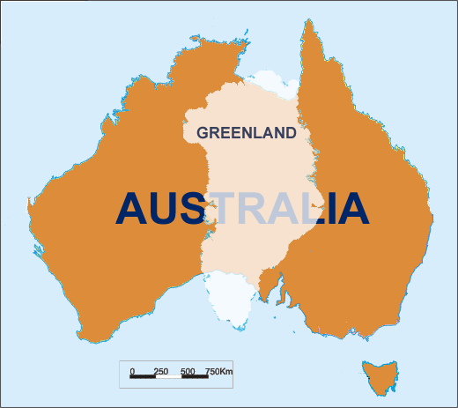
Tissot’s indicatrices for the Mercator projection Comparison between the size of Greenland and Australia

Activity 2: Taking into account the information from Tissot’s indicatrix, order again the following countries by size, from largest to smallest: United Kingdom, Spain, France, Poland, Sweden, Morocco.

1 |  |  | 4
2 |  |  | 5
3 |  |  | 6

Other projections

Activity 3: Classify the following maps according if you think that they preserve the areas, preserve the angles, or both.

Projection | Preserves area? | Preserves angles? |  | Projection | Preserves area? | Preserves angles?
Mercator | No | Yes |  | Azimuthal
Lambert |  |  |  | Mollweide
Plate Carrée |  |  |  | Robinson
Stereographic
Robinson
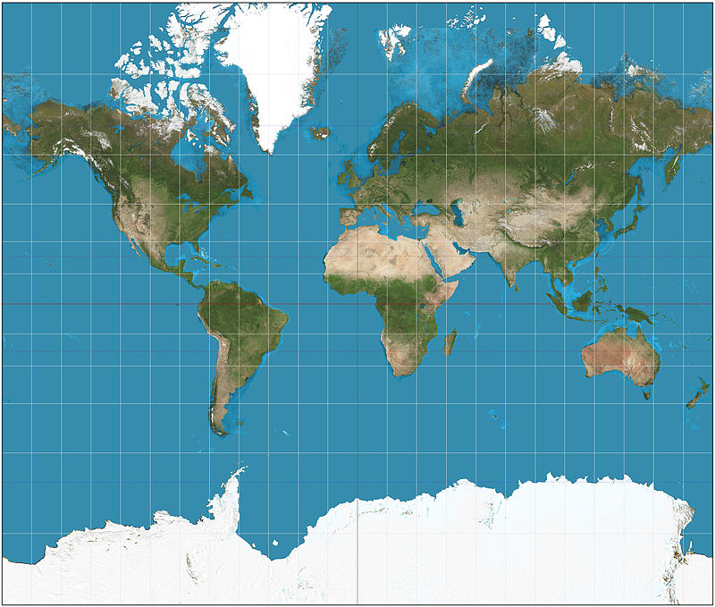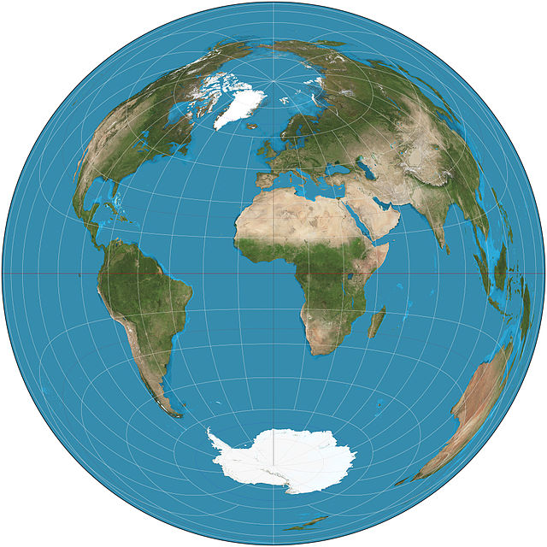
Mercator Lambert
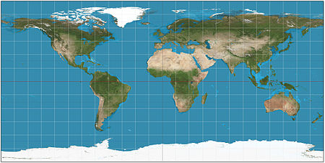
Equirectangular or Plate Carrée
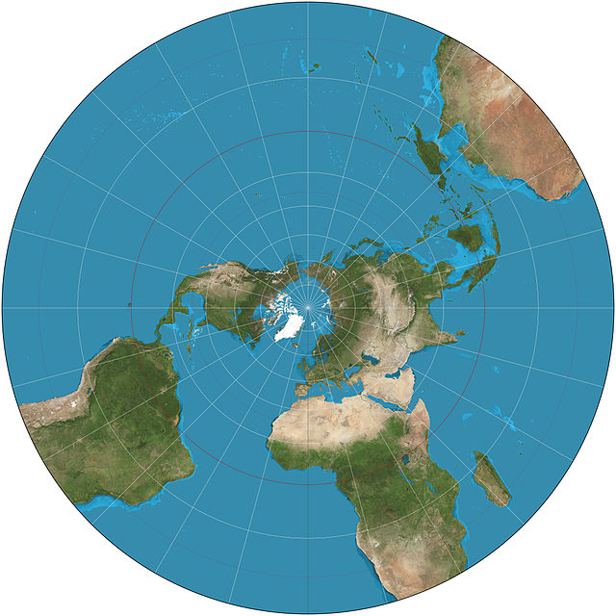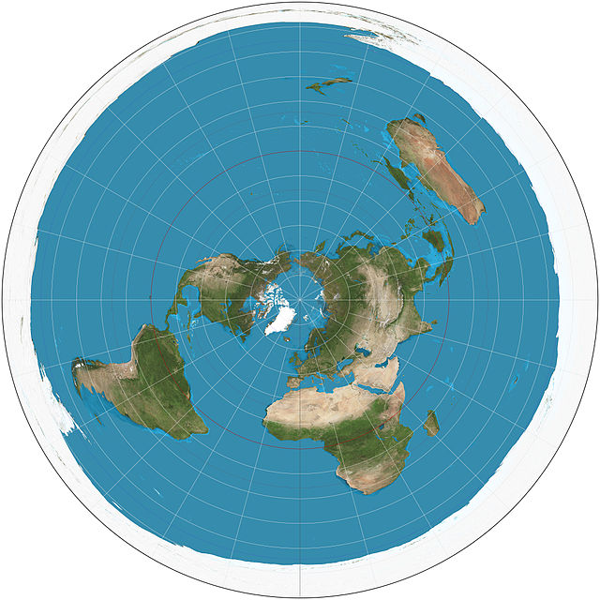
Stereographic Azimuthal
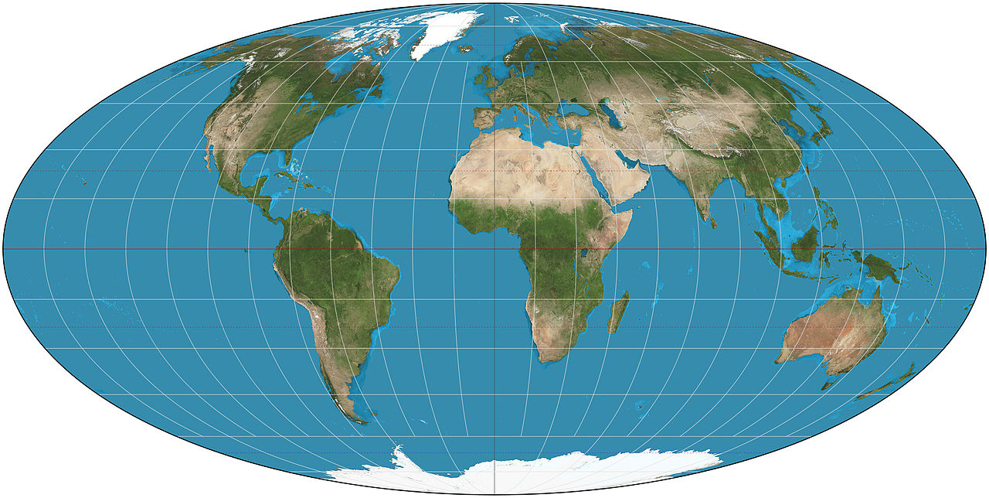
Mollweide
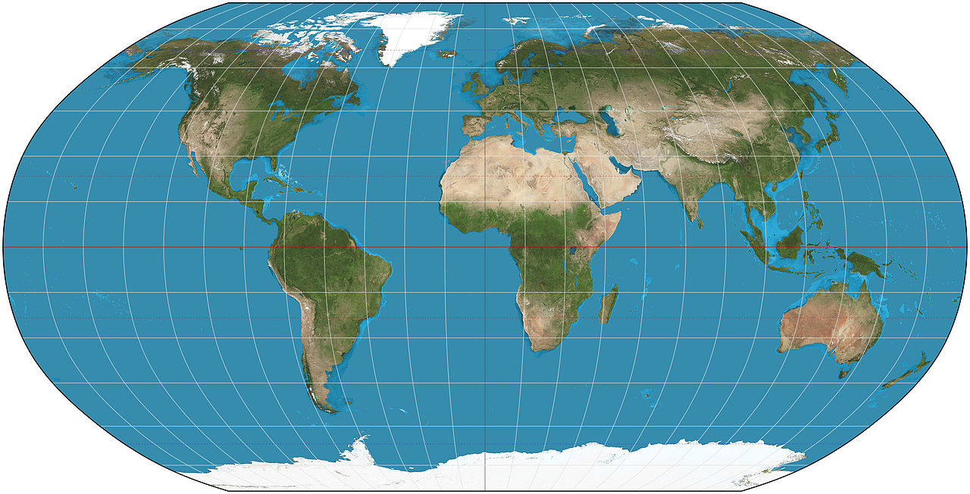
Robinson

Geodesics

A geodesic is a curve that minimizes the distance between two points on a surface. In the plane they are just straight lines. In the sphere these curves correspond to great circles, i.e. circles of maximum diameter, like the equator.
Activity 4: To fly from São Paulo to Tokyo which of the following places will you be flying over?
a) Canada b) Mexico c) Hawaii d) Argentina
And if you fly from Moscow to Mexico City?
a) United Kingdom b) Spain c) Greenland d) Brazil

Links to more resources

- The Wikipedia page on map projection gives a useful overview with links to further information:
http://en.wikipedia.org/wiki/Map_projection
- A powerful Java app allowing you to explore many different map projections (if you have difficulty getting the Java to work, email one of us and we can send you instructions):
http://www.uff.br/mapprojections/mp_en.html
- A website with informal descriptions of the key concepts in cartography – the science of making maps:
http://www.progonos.com/furuti/MapProj/Normal/TOC/cartTOC.html

We hope you have enjoyed our workshops. Please get in touch if you would like to find out more about the topics of these workshops, or if you have any questions about studying maths at university.

David Martí-Pete
email: David.MartiPete@open.ac.uk
website: users.mct.open.ac.uk/dmp387
twitter: @davidmartipete
Mairi Walker
email: Mairi.Walker@open.ac.uk
website: www.mairiwalker.co.uk
twitter: @mairi_walker

