Cryptic Challenge

Welcome to the cryptic challenge! In this session we’ll be looking at cryptography, which is the maths of code breaking. Here in Milton Keynes we’re lucky enough to be near to Bletchley Park, which during World War II was home to a secret team of code breakers, and is where Alan Turing famously cracked the Enigma code and helped us to win the war. Today you’ll get the chance to work as teams of code breakers in our cryptic challenge. Can you be the first team to crack the four challenge codes?

# Starter Activity

Decode the Pigpen cypher to find out what we’ll do in this session.

# Challenge 1: The texting challenge

Can you crack the texting challenge?

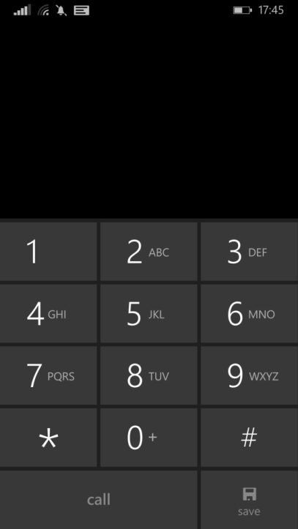

# Challenge 2: The transposition challenge

Use this grid to crack the transposition challenge.

|  |  |  |  |  |  |  |  |  |  |
| --- | --- | --- | --- | --- | --- | --- | --- | --- | --- |
|  |  |  |  |  |  |  |  |  |  |
|  |  |  |  |  |  |  |  |  |  |
|  |  |  |  |  |  |  |  |  |  |
|  |  |  |  |  |  |  |  |  |  |
|  |  |  |  |  |  |  |  |  |  |
|  |  |  |  |  |  |  |  |  |  |
|  |  |  |  |  |  |  |  |  |  |
|  |  |  |  |  |  |  |  |  |  |

# Challenge 3: The binary challenge

|  |  |  |  |  |  |  |  |  |  |  |  |  |  |
| --- | --- | --- | --- | --- | --- | --- | --- | --- | --- | --- | --- | --- | --- |
| **A** | **B** | **C** | **D** | **E** | **F** | **G** | **H** | **I** | **J** | **K** | **L** | **M** | **N** |
| 1 | 2 | 3 | 4 | 5 | 6 | 7 | 8 | 9 | 10 | 11 | 12 | 13 | 14 |
| **O** | **P** | **Q** | **R** | **S** | **T** | **U** | **V** | **W** | **X** | **Y** | **Z** | **!** |  |
| 15 | 16 | 17 | 18 | 19 | 20 | 21 | 22 | 23 | 24 | 25 | 26 | 27 |

# Challenge 4: The frequency analysis challenge



**Hints:**

* The most frequent two-letter words are OF, TO, IN, IT and IS.
* The most frequent three letter words are THE, AND, FOR, ARE and BUT.
* Half of all English words begin with A, O, S, T or W.

# Want to crack more codes?

The University of Manchester organises every year the Alan Turing cryptography competition! Registration opens in the beginning of December. Check out

[**http://www.maths.manchester.ac.uk/cryptography_competition/**](http://www.maths.manchester.ac.uk/cryptography_competition/)

for more details.

# Thanks to



Vasso Evdoridou

**email:** Vasiliki.Evdoridou@open.ac.uk

Matthew Jacques

**email:** Matthew.Jacques@open.ac.uk  
**twitter**: @MatthewJacques

David Martí-Pete  
**email**: David.MartiPete@open.ac.uk  
**website**: users.mct.open.ac.uk/dmp387

**twitter**: @davidmartipete